A 6DSAL Final Document Project
< Basic Restaurant Reservation System with CSV File Handling>
Presented to the School of Computing
Holy Angel University



Apostol, Lance Jezreel
Opiniano, Ezkylle
Romero, John Jabez
San Pedro, Adrian Elijah

October 20, 2024

Project Title: Basic Restaurant Reservation System with CSV File Handling

- Executive summary

  - The restaurant reservation system project shall be based on the simple development concept: making use of the First-In-First-Out principle in the handling of reservations and reading a CSV file in handling the storage of data. It shall be easy to use all basic operations such as adding, viewing, and canceling reservations with the data to be stored in a CSV file.

- Statement of Objectives

  - Problem:
    - The current management of restaurant reservations often leads to inefficiencies, such as double bookings or the inability to track reservations accurately. This project aims to develop a Basic Restaurant Reservation System that utilizes a First-In-First-Out (FIFO) queue model for managing reservations. By implementing a command line interface, the system will facilitate the addition, viewing, and cancellation of reservations while ensuring that all data is persistently stored in a CSV file. This system will streamline the reservation process, improve customer satisfaction, and minimize the risk of errors.

  - Solution:
    - This is a simple command line interface that can be used in the restaurant to manage reservations.
    - By using a reservation queue with FIFO.
    - Use CSV file handling to store and load reservations persistently.
    - Install the rudimentary capability of making, showing, and canceling reservations.

- Algorithm Scope

  - The system uses a queue; reservations are appended to the end and are processed in a FIFO order from the front. Information related to reservations in terms of name, party size, and reservation time is stored within a CSV file that makes sure data is preserved when the program run is complete. The program also reads from the CSV when started up to restore the reservation queue.

- Scope of Work

  - Design Requirement:
    - Develop a straightforward command line interface for the execution of the reservation queue.
    - Implement basic queue operations: Add, View, and Cancel reservations.
    - Use file handling to store and retrieve data in CSV format.
    - Include customer name, party size, and reservation time as fields in the CSV-like structure.

  - Developments

    - Implement queue functions: enqueue, dequeue, and cancel.
    - Utilize the Python csv module for reading and writing reservation data.
    - Support the main functionalities of creating, viewing, and canceling reservations.
    - Load existing reservations from a CSV file on startup and save the current queue to the file on exit.

  - Exception Handling:

    - Implement error handling for invalid inputs, such as non-numeric party sizes and improperly formatted reservation times.
    - Handle cases where the CSV file may be missing or unreadable, providing user-friendly error messages.
    - Ensure that operations on an empty queue (e.g., attempting to dequeue or cancel a reservation) are managed gracefully, informing the user of the current state

  - Testing:
    - Validate that all queue operations adhere to the FIFO principle.
    - Test the loading and saving of data to a CSV file, ensuring data integrity.
    - Conduct tests with common edge cases, such as an empty queue and invalid input formats.

  - Documentation:

    - Create a README file with clear, step-by-step instructions on how to run the program.
    - Include an explanation of the CSV file structure used for storing reservation data.

- Sample Output for Each Operation

  - Add Reservation Operation

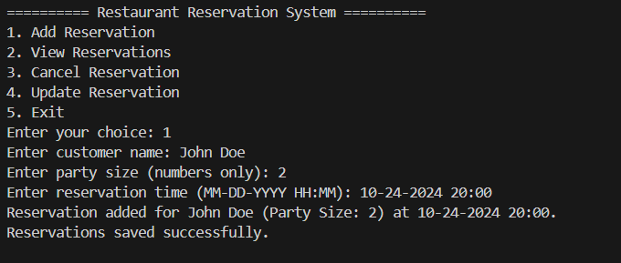

  - View Reservation Operation

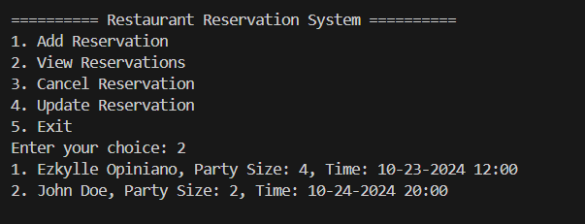

  - Cancel Reservation Operation

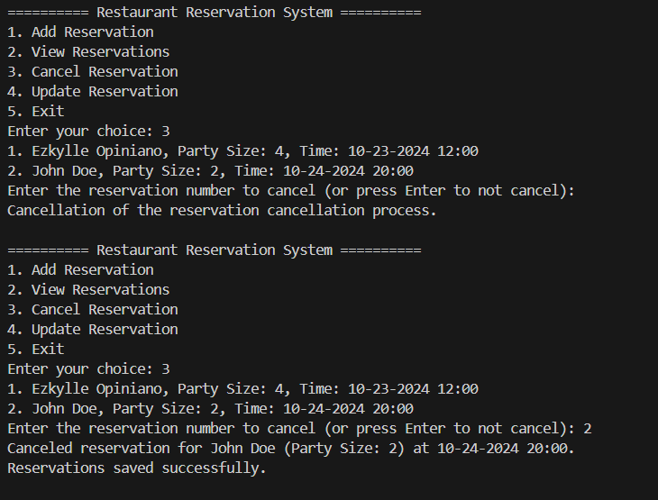

  - Update Reservation Operation

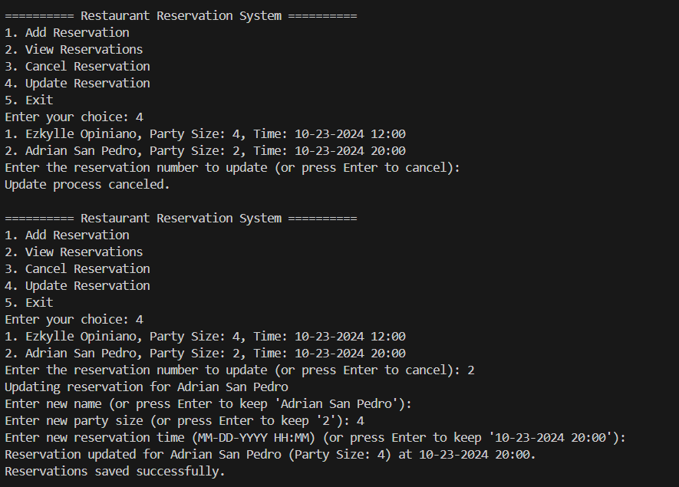

  - Exit Operation

